BIO 100 Applied Final: GMOs and Feeding the World
Please respond with a different color of font and include your original questions.
Objectives:
- Journey around the world and explore the use of GMOs and their application for feeding the world.….
- Determine your belief on the following: Are GMOs are a good thing for society or are we heading into dangerous territory in their use?
Directions:
- There are 12 Main “Thought Questions”.
- You will be asked to review the background information I have provided and visit the various articles and videos for each question.
- IMPORTANT: You MUST answer the “Thought Questions” in red at the beginning of each. Reading the associate article may help establish your response. ..
- You will then respond to the questions following the article.
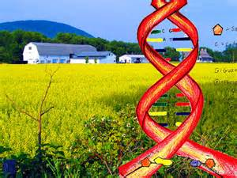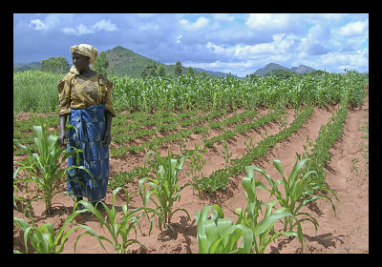

What are the ethical concerns regarding GMOs in the food industry?
“God (Nature in my view) makes all things good; man meddles with them and they become evil…" "― Jean-Jacques Rousseau; philosopher, 1770
"An ecosystem, you can always intervene and change something in it, but there's no way of knowing what all the downstream effects will be …" - Dr. Richard Lewontin, Professor of Genetics, Harvard University
"The controversy surrounding genetically modified organisms has real importance for society, there are complex scientific and logical issues to sort through, and the topic is rife with misinformation and motivated reasoning……" -Dr. Novella, academic neurologist; Yale University School of Medicine
Remember, the first step in ethical problem solving and policy decision making should first involve ascertaining the facts. Facts by themselves, however, only tell us what is; they do not tell us what ought to be.
Resolving an ethical issue also requires an appeal to values. Before tackling the GMO debate, let's review the five different approaches philosophers have developed to deal with moral issues.
After learning the science and obtaining facts, Keep philosophical approaches in mind when tackling the GMO issues.

- Utilitarian Approach: What benefits and what harms will each course of action produce, and which alternative will lead to the best overall consequences?

- Rights Approach: What moral rights do the affected parties have, and which course of action best respects those rights?

- Fairness or Justice Approach: Which course of action treats everyone the same, except where there is a morally justifiable reason not to, and does not show favoritism or discrimination?

- Common Good Approach: Which course of action advances the common good?

- Virtue Approach: Which course of action develops moral virtues?
(1) What is the GMO debate really about? How are politics involved?(30 points total, 4 points for essay and 26 for questions below)
The GMO Controversy

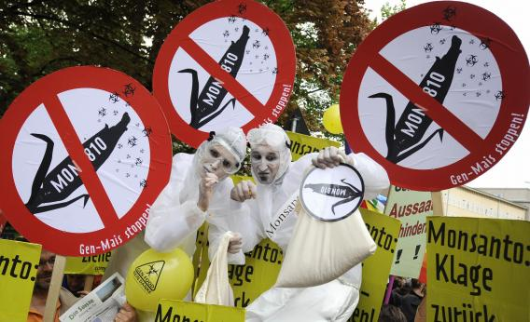
"GMO critics despise corporate control and greed, and fear the unnatural, while GMO advocates see this technology as an example of the triumph of human ingenuity and science"
http://theness.com/neurologicablog/index.php/the-gmo-controversy/
(26 points total: each short answer question is worth 1 point. Each T/F worth .5 point. )-
- beliefs concerning GMOs tend to be dominated by two opposing narratives: What are they?
- GMO advocates point out that pretty much all food that is consumed by humans has already been extensively modified by human activity. (True or False?)
- What was corn cultivated from?
- Cultivation uses a combination of what two basic processes to create countless varieties of common plants?
- What is artificial selection?
- What is cross pollination?
- Orange carrots are not the result of a mutation (True or False?)
- What is mutation breeding?
- How many mutagenic plant varietals were released between 1930 and 2007?
- What are the two basic types of GMOs?
- What is the difference between the two types of GMOs?
- What are the four types of GM plants currently approved for use?
- Contamination of genes from other kingdoms occurs, even in nature (True or False?)
- According to the American Association for the Advancement of science, GM crops are the most extensively tested crops ever added to our food supply. (True or False?)
- According to the article, studies comparing GM and non-GM potatoes, soy, rice, corn and triticale found that the GM and their non-GM counterparts are NOT nutritionally equivalent.” (True or False?)
- The National Academies of Science states that “To date, no adverse health effects attributed to genetic engineering have been documented in the human population.” (True or False?)
- What does the World Health Organization say about GM foods?
- Plants that are produced through hybridization, which can chaotically mix in hundreds of genes, and plants resulting from mutagenic breeding do not require the same safety testing currently required of GMOs. (True or False?)
- What are the advantages of herbicide resistant plants?
- What are the disadvantages of herbicide resistant plants?
- What are the advantages of pest resistant crops?
- What are the disadvantages of pest resistant crops?
- According to the article GM crops with insect and herbicide resistance can be useful and even protect the environment, but they have to be used as part of what type of strategy?
- What are the three major seed companies?
- What are some of the claims made against Monsanto that, according to the article, are not true?
- According to the article, the big seed companies have overhyped their own products and encouraged overreliance on their GMOs as a single solution to farming’s complex issues. True or False?
- Why are Monocultures counterproductive?
- According to the article, Seed companies should be encouraged to not just make one variety with a favorable trait, but do what?
- What are seven benefits listed for GMOS ?
- According to the article, Genetic modification is a powerful technology, and its impact will depend entirely on what?

(2) Explain your thinking on the safety of GMOs and the differences in attitudes between scientists and th public (30 points total: 6 points for essay and 24 for questions below)

Attack of the Killer Tomatoes?

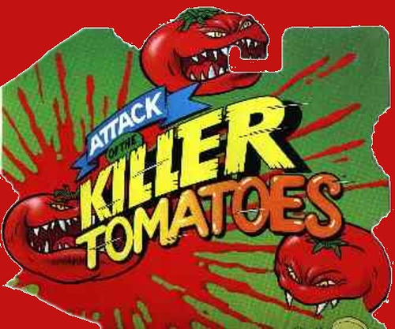

"On one hand, you have the proponents who are talking about the benefits of genetic engineering in terms of science. On the other, you have people in butterfly costumes."
http://www.scu.edu/ethics/publications/submitted/schulman/tomatoes.html
24 points total: (each question is worth 2 points).
- England's Prince of Whales claims that GMOs do what?
- Where does the Catholic church stand with regard to GMOs?
- Why does the author compare GMOs to microwaves and DDT?
- What type of harm has resulted to humans as a result of ingesting GMOs?
- What is the "Terminator gene" and what is the controversy surrounding it?
- Why are the risks of GMO being defined by those who are frightened?
- How long have GMOs been on the market here in the United States without the consumer knowledge?
- Under what conditions does the Food and Drug Administration require the labeling of Genetically modified foods?
- What might increase the consumer's trust in the use of GMOs?
- The United States has the Food and Drug Administration and Environmental Protection Agency to regulate food safety. Who regulates food safety in Europe?
- What disease occurred in Europe that ultimately put the blame on farmers and, according to the authors, led to a heightened fear of the food industry by Europeans?
- What is the consequentialism theory?
(3) Should companies be allowed to test or grow their productions around the world? How should countries work together to solve issues of world hunger? (25 points total; 5 points for essay, 20 for questions below)
The Future of Food:
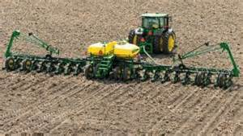

"A common approach to thinking about the ethics of the genetic engineering of food crops and the appropriate regulatory environment is by evaluating safety and weighing potential risks and benefits."
http://www.scu.edu/ethics/practicing/focusareas/medical/conference/presentations/genetically-modified-foods.
Directions: respond to the following questions for 20 points total. Point value follows each question.
- what are the most commonly grown GM crops in the US?( 5 points)
- What was the first GM organism? (2 points)
- what are the GM benefits for bananas, potatoes, peanuts and tomatoes? (2 points)
- Why did the California Food and Agriculture Department deny Ventria's request to grow GM rice? (2 points)
- What is INB Biotechnologies developing through the transgenic modification of petunias? (2 points)
- Describe four risks of GMOS (4 points)
- Describe three benefits for GMOs (3 points)

(4) What are the different technologies behind the controversy ?(10 points total: briefly describe 5 points essay response, 5 for questions below)
Video #1 Genetic Modification (5 min) http://www.youtube.com/watch?v=LSBnoGZoAHs
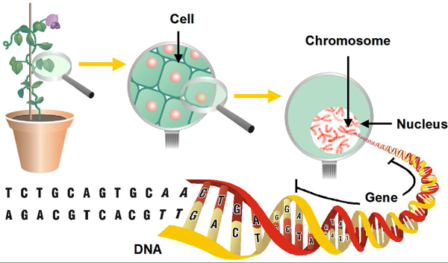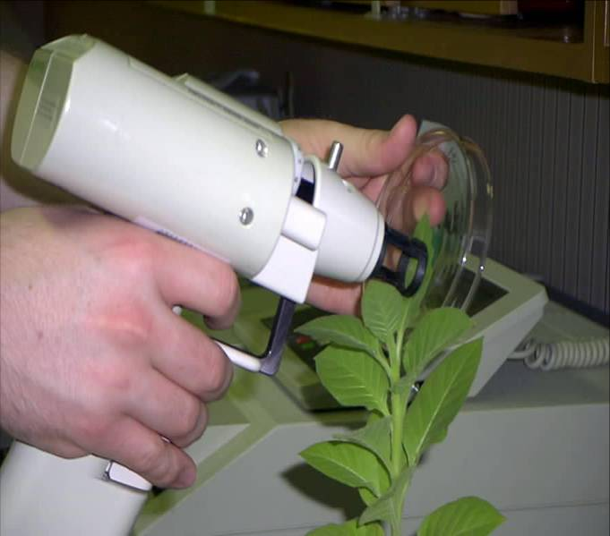
"The crops we see today are vastly different from those plants that existed at the dawn of civilization Since the beginning o agriculture farmers and gardeners have altered the genetic codes of plants and animals even if they were not aware of it at the time. …".
(each question is worth 2.5 points)
- Where did the Modified Bacterium approach to gene insertion come from?
- How does a gene gun work?

(5) Which course of action (spraying/ or GMO seeds) advances the common good? (Explain which type of technology you feel is the “right” one to utilize and WHY?- 15 points total:5 points essay; 10 points for the questions below)
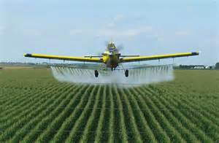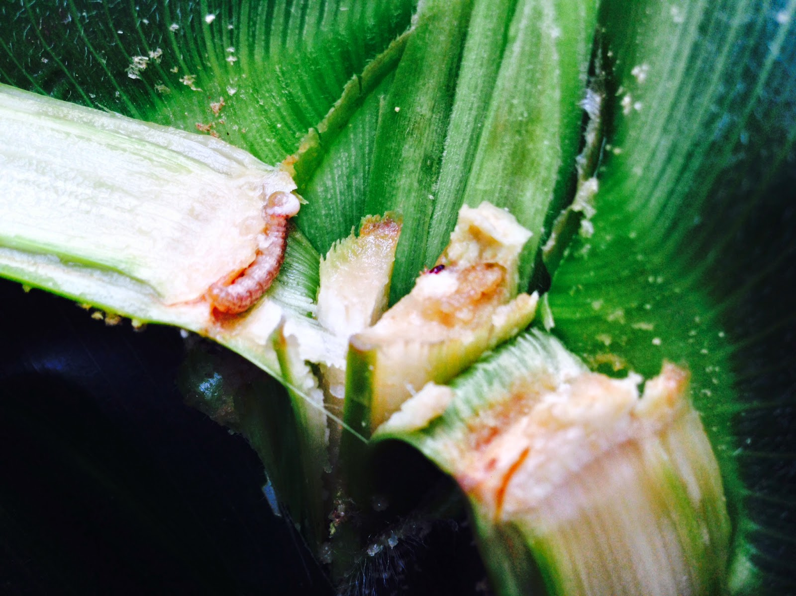
85% of the foods we eat come from large farms….Farmers want to know : " Can Monsanto's genetic technology help get rid of a big pest: the European Corn borer caterpillar?"
.Video #2 The Farmer's perspective: Evolution BT Corn Genes and Bug Genes (5 min)

https://www.youtube.com/watch?v=n9xpKx03g9M
Directions: Each question below is worth 2 points for a total of 10 points
- How specific can farmers get with conventional pesticide spraying techniques?
- Why would a farmer turn to GE crops for controlling insects?
- Is the BT toxin harmful to humans ? Is it harmful to most other insects?
- What did the Environmental protection agency mandate in order to deal with the issue of resistant pests?
- Who monitors whether or not the farmers are laying aside land for this area of refuge for insects?

(6) Farmers have been improving wheat for over 10,000 years….Do the benefits of GE crops outweigh any risks; why or why not? (20 points total: Essay 5 points and questions 15 points)

video #3 Public perception of GMO's: The eyes of Nye: Genetically modified foods
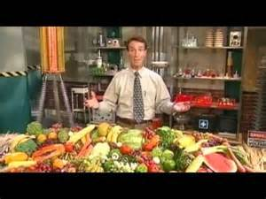
Directions: each question below is worth 3 points for a total of 15 points.
https://www.youtube.com/watch?v=l7qfhgTcqko
- How long does it take to get a domesticated variety of wheat using cross breeding
- 91 percent of all GE crops planted around the world belong to what corporation?
- Why was Dr.Sarah Hake opposed to lumping transgenic genes into one category?
- According Dr. Steven Jones (wheat breeder) researchers are using technology on problems that do not need solutions. What does he believe the real cure for world hunger is ?
- According to the film, we should do three things with regard to GMOs: (fill in the blanks)
  - farm____________
  - demand___________
  - test___________on a case by case basis

